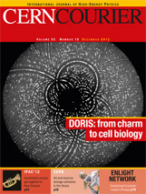 CERN Courier December 2012 Volume 52 Issue 10

INR awards the 2012 Markov prizes
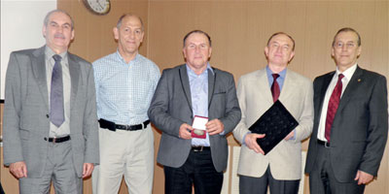
Awards
The Institute for Nuclear Research (INR) of the Russian Academy of Sciences in Moscow has awarded the 2012 M A Markov Prize to Nikolai Krasnikov and Boris Zhuikov, both of the INR. They received the awards at the 10th Markov Readings in Moscow on 12 May.
Krasnikov, one of the Russian leaders in quantum field theory and particle physics, is recognized for his contribution to the development of the theory of particles and quantum fields and elaboration of the research programme at the LHC. Zhuikov, who is head of the radioisotope complex at INR, is honoured for his elaboration of methods for producing special isotopes for medicine and new hardware.
The M A Markov Prize, which is awarded for essential contributions to theoretical and experimental studies in the field of elementary particle physics, nuclear physics and neutrino astrophysics, was established by INR in memory of Moizey Alexandrovich Markov (1908–1994), who was one of the founders of the institute. The Markov Readings are held on 13 May each year to commemorate his birthday.

